Todber Parish Meeting

Minutes of Todber Parish meeting

Held on the 23rd of April 2026 at 7.00pm at St Andrews Church Minutes are not Verbatim

Present: Vice - Chairman Stours Parish Council – to Chair the meeting

In attendance: Mrs N Phillips – Clerk – Cllr J Watkins – Chairman Stours Parish Council – 11 members of the public Cllr Bowe is the Vice Chairman of the Parish Council, he opened the Parish Meeting

1/26. Apologies for Absence
Doreen and John Penn and Dorset Councillor J Somper

2/26. Declaration of Interest and dispensations
There were none

3/26. To agree the Minutes of the meeting dated the 21st of October 2025.
The minutes were agreed and signed by the Vice - Chairman
RESOLVED: that the minutes were approved and signed by the Vice-Chairman (3/26)
DRAFT

4/26. Matters arising.
Update on the Millennium Green and Woods – Cllr Matcham gave the following update:
- The grass cutting has started
- Bulbs had been planted
- The field grass is dominant which does not help when planting wildflower seeds and plants
- The Rabbits are causing problems with any flower growth, they do enjoy eating them.
- Cllr Matcham is meeting with a Conservation Officer from Dorset Wildlife Trust to obtain advice on how to manage the grass and Rabbits. Results will be reported back at the Parish Meeting in October or before at a Parish Council meeting.
Consider defibrillator for the Parish – The following was discussed:
- As the Church has not given permission for a defibrillator to be erected there, the Clerk has been looking at other options.
- There are mobile defibrillators available but a designated person will need to have it in their home and be available 24 hours a day for access which was not felt to be viable.
- The Clerk confirmed there are solar powered defibrillators, it was agreed for the Clerk to obtain quotes. Action – Clerk
- The Clerk will obtain confirmation from Mr J Candy, that there is a defibrillator at the fishery, which is accessible to the public 24 hours a day. There is also a defibrillator at Stour Row, which could be used in an emergency.
- The PCC will also re-consider having the defibrillator at the Church, as the Clerk assured them that the defibrillator does not need to be attached to the building and the Parish Council would cover the cost for the electricity.
- The Clerk will also speak to Bartletts to see if they would donate a public defibrillator for the Parish. Action - Clerk Todber Church proposal to use for village hub
- The works to the roof have been completed and next three windows to be taken away for repair.
- The application for re-order of the Church is going ahead.
- The Church will continue to do fund raising events to keep the Church running costs are £10,000 a year.
Proposed speed reduction on the B3092 – Cllr Matcham reported the following:
- The 40MPH at Stour Provost crossroads has been confirmed and the roundels are in place, just waiting for the main ( legal)signs to be erected on the verges.
- The Parish Council will continue to work on the proposal for a 40MPH from East Stour to Marnhull. This was not progressed before as it was considered important to get the 40MPH at Stour Provost crossroads approved and put in place. It was felt a full application for the 40MPH could have had an adverse affect on the application for Stour Provost.
- It was suggested that Marnhull Parish Council and Stours Parish Council could work together on producing a document to Dorset Council with evidence of why the B3092 from East Stour to Marnhull should be all 40MPH. This will be discussed at the Stours Parish Council meeting.
- Could anyone that witnesses dangerous driving, or any accident report it directly to Dorset Council using the following link.
https://www.dorsetcouncil.gov.uk/news/tell-us-about-small-collisions-or-near-misses-to-help-us-target-road-improvements
- The Clerk has already reported the faded road marking on the junction off B3092 down to Red Lane, as this is on a dangerous bend and needs to be clear to all road users. The Clerk has also requested rumble strips on both sides of the road, heading to the bend, to encourage road users to slow down. The damaged chevrons have also been reported and requested replacement as soon as possible. If any resident would like to report road issues, drains ect, please email the

details to the following parties – The link for reporting potholes is https://www.dorsetcouncil.gov.uk/w/pothole-repairs and for blocked drains it is https://www.dorsetcouncil.gov.uk/report-a-problem-on-the-road-or-pavement . You can also use Fix My Street https://www.fixmystreet.com/
- Continued issues with flooding on Red Lane – a local resident gave an update on the ongoing issues of flooding on Red Lane. Unfortunately, Dorset Council have not been very responsive. The resident was informed that the Highways Officer who was dealing with this matter has changed his role in Dorset Council and that the actions agreed could take up to another 6 Months to put in place This was felt to be unexpectable. The resident spoke to the MP and other persons and was advised to take this further, as it was felt to be a service Issue, as Dorset Council have not fulfilled their obligations. The resident will copy correspondence with the Clerk, as Parish Councillors present at the meeting all agreed that the Parish Council will support the resident with the complaint.

5/26. District Councillor Report – Dorset Councillors reports can be viewed on the Parish Council’s website.

6/26. Update on Planning Applications

Cllr Matcham reported that Dorset Council will be putting their Dorset Plan out to the public early Autumn, this is an amended plan, from the previous public consultation last year. Todber did not have any allocations for development, but it was noted that Marnhull are looked at as an area that could expand even more, towards Todber. The proposed plan will be looked at by the Parish Council once released.

7/26. Reports from representative from local organisations and Councillors:
DRAFT
Reports had been covered under agenda item 4

8/26. Finance
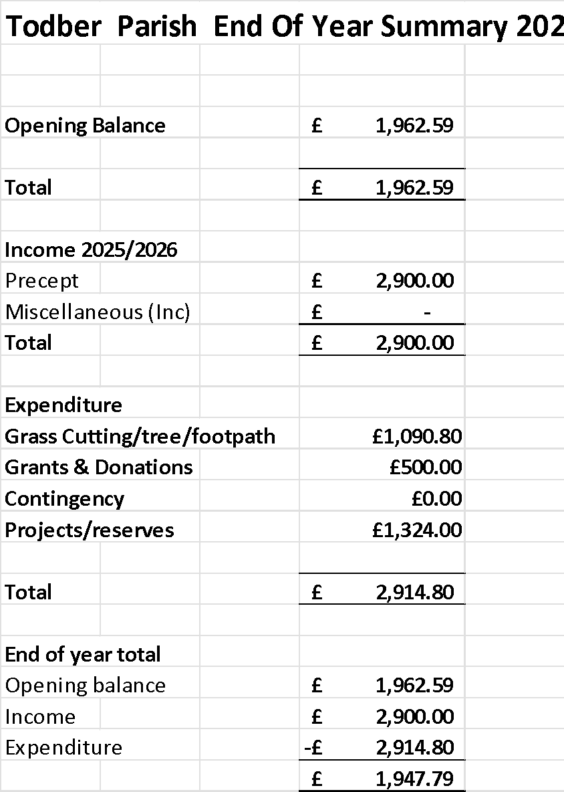
The Clerk had tabled the end of year summary for Todber Parish, which is as follows:

9/26. Matters of interest and information
The plant sale will be taking place on the 23rd of May 2026

11/26. Agenda items to be agreed for the next Parish meeting on a date in October 2026 to be confirmed. Ageda items – Defibrillator, Budget. Other items to be agreed.

There being no further business the meeting closed at 19.55 Signed…………………………………………………………………………………………
Website address http//: www.stours-pc.gov.uk
Should you wish to contact any Councillor please us the address clerk@stours-pc.gov.uk

